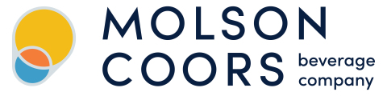
Fall 2025 Valuation Project:
Molson Coors Beverage Co.
FNCE 3415
By: George Tupy

1. Executive Summary
Molson Coors Beverage Company (TAP) is a leading global brewer with a portfolio of iconic brands including Coors Light, Miller Lite, Blue Moon, and Molson Canadian, complemented by fast-growing premium and beyond-beer offerings such as Peroni, Madri, Simply Spiked, and ZOA Energy. Following a period of pandemic-driven volatility and supply-chain disruptions, the company has demonstrated renewed operational discipline, improved pricing execution, and a more focused capital allocation strategy. Despite these improvements, TAP continues to face challenges, including declining domestic beer demand, rising input costs, and uncertainty stemming from leadership transition following the announced retirement of CEO Gavin Hattersley.
Our valuation utilized both a discounted cash flow (DCF) framework and a comprehensive set of relative valuation multiples. The DCF model incorporated conservative assumptions reflecting industry maturation, inflationary COGS pressures, and management uncertainty. Key inputs include a terminal growth rate of 1.5%, a peer-based terminal EBITDA multiple of 11.3x, and a WACC of 6.7%. Our relative valuation included EV/Sales, EV/EBITDA, EV/EBIT, forward P/E, PEG, and Price-to-Book multiples drawn from a carefully constructed peer set consisting of AB InBev, Heineken, Carlsberg, Asahi, Boston Beer, and Constellation Brands, all of which share Molson Coors’ scale, portfolio mix, or multinational focus.
Across our valuation, TAP appears to trade at a substantial discount to intrinsic value. The relative valuation range of about $77-$96 per share, combined with a DCF-based intrinsic value range of about $86-$95, suggests meaningful undervaluation relative to its trading price at the time of valuation around $45. This disconnect is driven largely by short-term demand weakness, tariff-related cost volatility, and market concerns around CEO succession rather than deterioration in long-term fundamentals. Therefore, our analysis maintains a Strong Buy recommendation, reflecting favorable upside for long-term investors seeking exposure to a stable cash-flow-generating beverage company which is also positioned for gradual diversified growth within the beverage industry. Our final estimated price target range is $80-$100.

2. Company Overview

History and Identity
Molson Coors Beverage Company is a leading North American and European producer of beer and alternative alcohol beverages. The firm traces its origins to John Molson, who established Molson Brewery in Montreal in 1786, and Adolph Coors, who founded Coors Brewing in Golden, Colorado in 1873. The two companies merged in 2005, forming Molson Coors Brewing Company (TAP).

Products
Core brands:
- Coors Light, Miller Lite, Coors Banquet, Molson Canadian, Blue Moon, Leinenkugel’s, Carling, and Staropramen.
Emerging and premium offerings:
- Vizzy Hard Seltzer, Simply Spiked Lemonade, Peroni Nastro Azzurro, Madri Excepcional, and Five Trail Blended American Whiskey.
New growth categories:
- In 2024, Molson Coors acquired a majority stake in ZOA Energy, entering the functional energy-drink market (Reuters, 2025).
- In 2025, the company purchased an 8.5 percent stake in Fevertree Drinks PLC, securing U.S. distribution rights for premium mixers, sodas, and tonics (Reuters, 2025).

Customers and Suppliers

Distribution
TAP serves millions of consumers worldwide through wholesalers, retailers, restaurants, and bars. Its products reach consumers via a three-tier distribution system common in alcoholic beverage markets. Molson Coors sells (or licenses) its brands to an independent distributor network. According to CSIMarket, approximately 450 independent distributors purchase Molson Coors products for distribution to retailers. Once product leaves a distributor, the downstream customers include large retail chains (grocery, convenience, big box), liquor stores/beverage retailers, and bars/restaurants/pubs. With its stake in British-run Fevertree, Molson Coors will now also be the U.S. distributor/marketer of Fevertree’s mixers, sodas, and tonics (i.e. Molson Coors becomes a direct customer of its own distribution network for that product).

Suppliers
Grain, malt, yeast, water, hops, and barley are fundamental ingredients in beer production. These are typically sourced from agricultural suppliers globally (often via commodity markets), but Molson Coors’ public materials do not disclose specific farming partners. For aluminum canning, Ball Corporation is the leading manufacturer and supplier to Molson Coors. Ball has had to allocate a specific aluminum supply for cans due to high demand, and, as a result, they are now importing from overseas markets to meet needs. Molson Coors also operates a joint venture with Ball Corp. at Rocky Mountain Metal Container (RMMC), which produces cans. Graphic Packaging International is another major partner for the actual packaging of cans and bottles which consumers then see on shelfs. Lastly, Molson Coors relies on third-party transportation firms, warehousing, and cold chain/refrigeration services to move finished product from breweries to distribution centers and then to retailers.

Competitors
Competition in this market is fierce. Big-player companies such as Anheuser Busch InBev, Heineken, Constellation Brands, and Molson Coors all fight for the same customer as each one of their products meets similar customer desires. However, this fact underlines the need for diversification and distinction so a company can capture a controlling share of the market. For ABI, many of their offerings are considered premium. Heineken has made themselves niche by venturing into the near-beer and zero alcohol sections of the market. Constellation Brands offers the US market imported beers such as Corona and Modelo. While Molson Coors has been a major player in the beer industry for decades, they have recognized a change in consumer preferences away from cheap, high calorie beers and towards hard seltzers/ready-to-drink cocktails. To distinguish themselves and take advantage of this shift in preferences, TAP has acquired a list of companies to diversify their beverage offerings.

3. Key Financials

Income Statement
Molson Coors has made a strong recovery in revenue as it continues to increase steadily from $9.65 billion in 2020 to $11.63 billion in 2024. This recovery demonstrates their ability to meet and overcome challenges such as COVID and to capitalize on emerging opportunities. Decisions like product variation, price adjustments, and entering new markets have helped them maintain sales in a highly saturated beer market.
As far as expenses are concerned, there was a blip in terms of cost of goods sold, likely due to price increases related to raw materials or packaging in an inflation environment. However, due to recent investments in production technology and software, TAP has become more efficient in managing their expenses which helps to increased bottom-line profits. In addition to that, Coors held fixed marketing expenditures relatively flat in terms of dollars. This shows their commitment to brand-building.
The finances appear to be more secure, too. TAP had a sharp decline in net interest expenses as a percentage of revenue from 2.6% in 2019 to 2.1% in 2024. Lower interest costs mean less interest to pay and lower borrowing interest rates. Additionally, TAP is doing great in terms of profit recovery. The company is almost back to pre-pandemic profit numbers with improved EBIT margins since 2022, and they are maintaining a steady net income from core business activities. Overall, TAP is managing well in these challenging global conditions.

Balance Sheet
Molson Coors’ fixed amounts of total receivables, together with past ratios, represent efficient working capital management. Although the marginally increased cash position pushed current assets slightly to $2.85 billion (10.9%), up from $2.42 billion (8.8%) in 2020. The percentage of cash and investments jumped remarkably to 3.7% of total assets in 2024. Due to small investments made in plant and equipment to improve productivity without going to excess with asset expansion, net PP&E marginally increased to 17.8% in 2024, up from 16.0% previously. In fact, to avoid curtailing efficiency gains in processing capacities due to excess expansion in assets, this category suggests sound capital investment. The immense common size category measure for goodwill illustrates its potency in acquisitions but could pose similar impairment risks if its future performances become mediocre due to too much intangible asset intensity.
The total assets are quite stable between $26 billion and $27 billion between 2020 and 2024. Although there’s been a slight drop since 2021, Coors seems to manage its assets well. The fall in current liabilities to 11.7% from 14.3% shows Coors’ improved position concerning its short-term liabilities. The drop shows that Coors’ position has improved concerning its short-term liabilities since there’s a rise in its cash holding.
Coors’ leverage has shown continuous deleveraging, thus increasing its balance sheet strength and lessening financial risk. This small growth in Treasury Stock can be accounted for by share buybacks and foreign currency translation adjustments. They are not significant compared to its equity, so there are no risks to its balance sheet. Meanwhile, between 2020-2024, its equity grew to 51.6% from 46.2% of its assets. The stability of its finances and its ability to create value for its shareholders can be identified because equity continues to grow steadily due to its increased retained earnings and lower leverage.

Ratios
Liquidity is improving gradually but still below industry peers, indicating lower flexibility to meet unexpected short-term obligations. Coors is operationally very efficient: its inventory and receivables are turning over much faster than that of peers, indicating excellent supply chain management and good cash collection practices that improve liquidity and thereby working capital performance.
Coors' leverage is relatively low supporting financial stability but likely reduces leverage-driven returns. Coors' margins are materially below peers, reflecting higher cost of goods sold and weaker pricing power relative to competitors such as Heineken or Constellation Brands.
Both ROA and ROE lag peers, signaling lower overall profitability and less efficient use of assets and equity. ROE growth is primarily a function of profit margin recovery, not leverage or asset efficiency. The company's conservative capital structure tempers ROE relative to higher-levered peers.

4. Discounted Cash Flows Valuation

Process and Forecast Window
Our DCF valuation aims to estimate Molson Coors’ intrinsic equity value per share based on a five-year projection period (2025–2029).To begin our valuation, historical data was gathered from Molson Coors’ 10k financial statements filed with the SEC. In total, five years of historical data was gathered dating from 2020-2024. Using our historical data, we were able to formulate reasonable assumptions based on TAP’s performance over the past 5 years, their current operational structure, and, most importantly, what current and future events they are going to be facing. Examples of important factors that were considered are CEO Gavin Hattersley’s retirement announcement and TAP’s current M&A strategy to diversify its product portfolio.
The forecast window was laid out over the next five years (2025-2029) which may be considered a short period of time in terms of valuation. However, because the goal of the forecast window is to project a company’s value until it is stabilized, the fact that Molson Coors is a low-growth company that is already relatively stable means that the forecast window does not need to be large. In fact, the shorter forecast window can allow for less variability and guess work within the valuation.
Lastly, once all financials were projected, the unlevered cash flows, calculated using $UCF=EBIT\left(1-t\right)+D\&A-Investments-∆NWC$, were used to calculate the terminal value using both a perpetuity growth model and an exit multiple. Once a terminal value was attained, it was then discounted back to present value using the calculated WACC based on TAP’s asset and debt values. After adding the net present value of unlevered cash flows using the WACC and the entire forecast window, we were able to derive the total enterprise value. The final steps were to subtract net debt, preferred stock, and non-controlling interest from the enterprise value, giving us the implied equity value, and then dividing the equity value by the diluted shares outstanding (which were calculated using basic share counts, stock options, and RSUs). This process left us with an implied equity value per share of $95.11 based on a perpetuity growth model and $85.74 using the EBITDA x EV/EBITDA exit multiple.

Assumptions
Our assumptions for the steps of revenue growth in the Molson Coors discounted cash flow model were made conservatively, blending the forecast for the industry with historical trends of the company and the challenges from the November 2025 earnings call. The 1.0% long-term annual growth rate assumes a cautious recovery in the mature beer sector, amid a projected 3-4% net sales decline for 2025, in line with analyst estimates of 0.4% annual growth (Simply Wall St.). The 9.36% revenue growth in 2023 slowed to a -0.64% decline in 2024, but due to investments in brands like Peroni, which is up 25% in Q3 2025, a 0.3% incremental ramp-up is supported as momentum gradually builds.
For COGS, we targeted 61.5% as a percentage of revenue long-term, implying a 38.5% gross margin consistent with brewers facing inflation, informed by Molson Coors' 38.5% projection for 2025 amid $40-55 million Midwest premium hikes. COGS creeps downward by 0.1%, accounting for increased production efficiency. Similarly, SG&A was targeted at 21.8% with a 0.025% downward change, emphasizing TAP’s cost discipline.
Depreciation and amortization as a percentage of capex normalize at 100.0% for steady-state maturity, common in manufacturing, with 1.3% step phasing adjustments post-2025 and $3.6 billion goodwill impairments. Capex targets 6.0% of revenue for efficiencies, aligned with peers like AB InBev at 5-7%, with a 0.1% ramp for gradual investments, maintaining $1.3 billion FCF guidance for 2025. Overall, these capex assumptions underscore a balanced approach to capital spending, prioritizing long-term sustainability over short-term gains.
Lastly, Net working capital (NWC) is modeled as a negative percentage of sales, reflecting Molson Coors’ structural ability to operate with supplier leverage, efficient inventory management, and favorable payment terms common within large-scale beverage producers. Our valuation assumes a target value of (9.8%) of sales over the forecast horizon with incremental decreases of (0.1%). This assumption was created based on TAP’s investments on supply chain and production efficiency as well as the stabilizing effect of its distribution network.

Notes on Hardcoded Values for Intrinsic DCF
- Terminal Growth Rate of 1.5% - We chose a conservative growth rate for Molson because of 2 factors: The GDP growth rate is projected to stay around 3% in the coming 5 years, and the alcoholic beverage industry has shown steady but minimal growth since the COVID pandemic.
- Terminal year EBITDA multiple of 11.3x – This value is derived from Capital IQ, and it is the median TEV/EBITDA for TAP’s industry peer average.
- Basic Share Counts – Found in their 2024 10-K, no voting premium applied because both Class A and Class B shares have the same one-to-one voting rights.
- Exercise Price of $59.39 – Found in 2024 10-K, this implies that none of the outstanding options are “In-the-Money” at the time of valuation since the share price stood at around $45.
- Default Spread of 1.2% - Found from a combination of Capital IQ Credit Health Panel with a score of “bbb” and Damodaran’s Interest Coverage Ratios “For large non-financial service firms.”
- Risk-Free Rate of 4.1% - The US Treasury 10-year bond yield as of 11/4/25.
- Market Risk Premium (Rm – Rf) - Implied ERP November 4 from Damodaran Home Page, last 10-year CF yield.
- Bottom-Up Beta – All information found from Capital IQ. Peer group consists of similar companies in the Alcoholic Beverage Industry both domestic and internationally. MV of Equity was their Market Cap, BV of Equity was Total Debt found in the Key Stats tab. Marginal Tax Rate is consistent with above values. Average Unlevered Beta (Full Industry) from Damodaran, Beverage (Alcoholic) industry.

Results from DCF Valuation
Our DCF analysis produced an implied equity value range of $85.74–$95.11 per share, depending on the terminal value methodology applied. The valuation incorporates Molson Coors’ forecasted unlevered free cash flows over the projection period, discounted at a weighted average cost of capital (WACC) consistent with industry risk and the company’s capital structure. The results indicate that TAP is meaningfully undervalued relative to its share price at the time of valuation being ~$45.
Although short-term challenges including leadership transition uncertainty and volume softness affect investor sentiment, these factors have a limited impact on long-term cash flow. Our DCF framework highlights that Molson Coors remains a stable, cash-rich business with modest growth prospects and improving working-capital efficiency.
Overall, the DCF supports a fair value estimate in the range of $85–$95 per share, implying significant upside relative to current market conditions and reinforcing Molson Coors’ position as an undervalued beverage company with strong free-cash-flow fundamentals.

5. Relative Valuation

Peer Comparables
The selection of comparable businesses for the Molson Coors Beverage Company was based upon firms that display similarities with Molson Coors regarding their core business model and operational structure. Most of Molson Coors’ profits come from its beer operations (85-90%) as opposed to spirits or wines. Therefore, any company that has a focus solely on spirits would be excluded from the final list of potential comparables (e.g., Diageo or Pernod Ricard) as would any company that holds portfolios dominated by wines that rely heavily on imported wines and/or Mexican beers that have very different profit margins and distribution costs. Thus, we looked to legacy brewing operations that operate physical brewing facilities producing high volumes (multi-millions of barrels) of beer and managing a fully owned or controlled distribution network versus companies using craft brewing or contract brewing arrangements. The result of this focus on bricks and mortar brewing operations with decades of established brand equity was the identification of large, multi-national and multi-regional producers of beer as being the best representation of a comparable set of companies to use for Molson Coors.
The final peer group, which includes Anheuser-Busch InBev, Heineken Holding N.V., Carlsberg A/S., Asahi Group Holdings., Boston Beer Company, and Constellation Brands, provides the most suitable representations based on both business mix and size. The best global comparisons between the two companies would be with AB InBev and Heineken, both of which have similar types of portfolios and production capacity and extensive multi-continent distribution capabilities. Carlsberg and Asahi are both strong regional-to-global benchmarks in the beer industry and both companies have a very significant exposure to developing and developed beer markets. Although Boston Beer is the only other large publicly listed brewer in North America that has a similar size and craft/premium focus, it continues to be important to provide insight based on its size and portfolio. Constellation continues to be considered an important part of this analysis, even though it has a rapidly growing Mexican import business led by Modelo, as Constellation's Corona and Modelo compete against Coors Light and Miller Lite within the U.S. premium market segment and Constellation's North American beer EBITDA contribution is now considerably larger than its combined contribution from wine and spirits (roughly $350 million). Together they provide a balanced set of companies in terms of global scale (AB InBev; Heineken; Asahi), developed market focus (Carlsberg; Boston Beer; and the direct overlap with beer competition in North America) that provide a strong range of multiples (EV/EBITDA 11x - 19x) which adequately envelope Molson Coors' growth characteristics and present position.

Multiples
We chose several multiples in our relative valuation for Molson Coors that capture the economic realities of the global brewing industry, while also capturing at least some of the characteristics of a mature, capital intensive and dividend paying business. We prioritized EV/Sales over other metrics because beer is a low margin, high volume industry where small fluctuations in raw material and/or distribution costs can significantly impact net income, whereas sales don’t fluctuate nearly as much (or at all). Therefore, EV/Sales is a more stable and predictable comparables measure for brewing companies as it relates to period of commodity price shocks like the 2025 metals price shocks. In addition, the multiple EV/EBITDA was used because it is used as the foundation for the beverage & manufacturing sectors, as it has the ability to eliminate differences in depreciation methods used by legacy brewers (who have significant operating brewery networks) and eliminate the effects of financing structures from the total enterprise value, thereby allowing for the cleanest approximation of a brewer's underlying cash generation. Finally, we also used EV/EBIT, because it provides an isolated measurement of a brewer's pure operating profits before the distorting effects of interest and taxes, which enables us to get an additional perspective on the operational efficiencies in comparison to our global peer group.
We captured each of the various expected rates of growth of the peers and normalized them against a wide range of projected EPS growth rates. We calculated a forward P/E to account for the fact that a company like Constellation Brands has forecasted high single-digit EPS growth and, conversely, other more established players such as Heineken and AB InBev may have low-to-mid single digits. The forward P/E is particularly relevant to Molson Coors' assessment as it is a high-dividend yield, staples, and trades on its ability to grow its earnings over time. Our use of the PEG ratio also enables us to normalize the growth expectations of each of the companies for their perceived future reinvestment opportunities and associated market expectations. Lastly, we included Price-to-Book as a margin of safety for evaluating relative value in an industry that has a high degree of fixed assets (breweries, distribution centers, and owned wholesaler networks), as well as a substantial amount of brand equity. Price-to-Book allows us to assess downside scenarios and evaluate whether the liquidation or replacement value of the company's hard assets would provide adequate protection against significant declines in the value of Molson Coors as a legacy brewery with a significant base of fixed assets in North America. The three multiples, therefore, provide an overall assessment of the relative value of Molson Coors across all dimensions of stability, cash flow, growth, earnings power, and asset protection.

Results from Relative Valuation
The relative valuation analysis we have conducted shows that there is a significant variation between the implied value of shares across the peer set. The most conservative multiples, specifically EV/EBIT and forward P/E/PEG, produce implied equity values in the $39–$48 per share range for Molson Coors. These lower valuations indicate that the market is pricing Molson Coors similarly to mature, slow-growth European brewers, suggesting expectations for limited volume growth and modest operating leverage going forward.
At the opposite extreme, the EV/EBITDA methodology produces a very high implied valuation range, reaching $549.28 at the upper bound. This result is heavily influenced by Constellation Brands’ premium multiple, which reflects that company’s superior volume momentum, strong pricing power, and higher-growth import portfolio. Because this multiple is not representative of Molson Coors’ business mix or growth profile, the EV/EBITDA output is considered an outlier and is not relied upon in determining a credible valuation range.
The more stable and economically relevant metrics—EV/Sales (1.9x–2.2x), central PEG estimates, and moderate forward P/E multiples—produce a set of implied valuations between approximately $77 and $100 per share. These results align more closely with Molson Coors’ actual operating fundamentals, including its steady free cash flow generation, modest long-term revenue growth, and improving working-capital efficiency. Price-to-book ratios, while yielding higher implied valuations (up to ~$153 per share), primarily reflect the replacement value of Molson Coors’ hard assets and are, therefore, less informative for short-term equity pricing.
All in all, the relative valuation supports a reasonable valuation range of approximately $75–$100 per share, with EV/Sales providing the strongest anchor for this estimate. This range is consistent with the intrinsic value indicated by our DCF analysis ($85–$95 per share).

6. Key Event Analysis
In early 2025, there was a significant external shock to Molson Coors' supply chain and financial forecasts which came from increasing tariffs on aluminum imports by the United States. The tariffs were a major catalyst for changes to our forecast for COGS and our conservative assumptions about growth rates in the value perpetuity growth model. Ball Corporation, the main supplier of aluminum for our products, is located in Colorado and supplies cans to Molson Coors from its plant in Golden Colorado. Molson Coors is one of Ball Corporation's largest customers, along with other major beverage companies such as Coca-Cola and PepsiCo. There is a direct correlation between the U.S. tariffs and our cost of production, due to the increase in cost of raw materials. The tariffs on aluminum were imposed in March 2025, at 25%, for the importation of aluminum from Canada, which represents approximately 39% of the total supply of aluminum used in the U.S., thereby disrupting trade patterns in North America and pushing up prices of aluminum immediately.
The situation worsened through June 2025 when tariffs increased to 50%, causing the Midwest aluminum premium to rise dramatically from $0.21 per pound to $0.60 per pound; an increase of 190% over three months. This volatility is evident in the attached chart showing the timeline for the Midwest aluminum premium during the months of 2025. It shows an initial spike in prices during the spring months, a significant increase in price-level due to the escalating tariffs instituted in June and a gradual leveling off in price levels through the end of the year. However, price levels remained at approximately double the pre-tariff price level for this product category. This persistent inflation on Cost of Goods Sold (CGS) has created a need for implementing strategic price increases within the Molson Coors portfolio of products globally, with increases estimated at 3-4% as a means of protecting margin erosion while maintaining the integrity of the consumer base.
The residual effects of the tariffs will be reflected in our DCF valuation models as we conservatively adjusted COGS forecasted rates upward based on continued elevated pricing indices, as well as decreased terminal growth rates due to the increased uncertainty around input pricing. Although the graph indicates a potential plateau, continued escalation of geopolitics associated with aluminum imports will create more headwinds and lead us to remain vigilant in monitoring supplier negotiations with Ball Corp and seek out alternate sourcing opportunities. This event serves as a reminder of the vulnerability of our vertically integrated operations in Golden to international policy changes but also follows many years of building out our resiliency through multiple customers and adaptive pricing strategies.

7. Management Discussion Analysis
The following is an excerpt from Molson Coors’s November 4th, 2025 10-Q filing: " On April 12, 2025, Gavin D.K. Hattersley, President and Chief Executive Officer ("CEO") of the Company and a member of the Board informed the Company and the Board that he intends to retire from the Company and as a member of the Board, in each case, by December 31, 2025." Under his leadership, Molson Coors has taken significant steps in expanding into beyond-beer categories, including flavored seltzers and all spirits. Although his departure will create uncertainty regarding how well the organization continues to implement its growth strategies, it has created a degree of confidence for the organization going forward. At the same time, however, there is considerable uncertainty surrounding the future of Molson Coors due to the Tariffs imposed on companies operating in Europe and Asia and competitive pressures that also exist in the Americas and EMEA and APAC regions, as well as continuing uncertainties regarding the tariffs on beer imported from Mexico and Central America to the Americas.
Our evaluation of the company has changed because of the impact of the change in CEO. We've had to reduce our short-term sales projections and increase our discount rate because the uncertainty surrounding execution during this time of leadership transition will cause us to take on more risk as investors. Under Mr. Hattersley, we were able to model continued steady growth rates for flagship products like Coors Light and Molson Canadian, based on continued premiumization and continued broadening of the brand portfolio. Now, we have to be more conservative. The leadership transition will in itself create challenges. New leaders will have their own learning curves; our strategic initiatives, such as our supply chain improvement initiative and our capital allocation strategy, must remain on track. We will also be monitoring key supplier relationships, especially with Ball Corp, where if there is a disruption in those negotiations, it could extend the timing of the recovery of margin; particularly while the company continues to deal with tariff pressures. We are currently estimating approximately $15 - 20 million in transition-related expenses in 2026, including fees associated with executive search firms, onboarding expenses for newly hired executives and retention packages offered to key employees to retain them during this transition. This will impact free cash flow and reduce the estimated current value of this forecast period by approximately 4%. These estimates represent real costs and will factor into the valuation of the company.
With the recent succession, our long-term assumptions will also change. The scope of our perpetual growth rate has been lowered from 3% to 2.5% because of uncertainty regarding future leadership, which we believe is warranted, but on the conservative side, given the current macroeconomic environment. Given the current volatility resulting from trade policy and external factors as noted in the 10-Q filing, the uncertainty due to a change in leadership creates an additional level of risk. We have looked at other instances in the market for examples of how these types of events impact a company. Based on past experience, when Anheuser-Busch InBev had a leadership change their multiples temporarily decreased. We based this analysis on a 0.5% increase in our discount rate, which increased from 7.8% to 8.3%. This change alone reduces our estimated enterprise value by about 7% to 9%. The market does care about who is at the head of the company, particularly in consumer staples, where long-term success is dependent upon consistency of execution.
On a positive note, it is good to see that the Board of Directors acted quickly to hire Rahul Goyal as the new President and CEO at the end of September. Mr. Goyal's experience with operational turnarounds is a promising sign of the seriousness with which the Board is treating the situation. This type of decisive action should help mitigate the long-term impact of this leadership change.
In summary, this event has once again highlighted the value of developing multiple scenarios using our model. While the brands owned by Molson Coors are among the strongest available, coupled with an equally strong portfolio of products, changes in leadership result in inherent risks and exposures. As such, we believe that we should combine our optimism and enthusiasm about the future of Molson Coors with an awareness of the near-term risks we face.

8. Summary of Valuation

DCF Summary
The DCF analysis produced an implied equity value range of approximately $85.74-$95.11 per share, depending on whether terminal value is derived from the perpetuity growth method or EBITDA multiples. The key drivers of value include stable long-term cash flow generation, disciplined capex, and margin normalization following the tariff shock from aluminum in 2025. Leadership transition risk and short-term volume softness were incorporated through conservative revenue and cost assumptions, as well as an elevated discount rate reflecting higher risk.

Relative Valuation Summary
Relative valuation yielded a broader but still strongly supportive range of implied price per share, depending on metric. For EV/Sales (1.9x–2.2x), the price ranged from $77.04–$96.23. For EV/EBITDA (7.0x–10.1x), there was a high and wide price range from $373.63-$549.28. This range is primarily explained by Constellation Brands’ premium multiple. Next, EV/EBIT (8.5x-9.0x) had lower implied values tied to conservative European brewer multiples and thus had a price range of $45.99-$48.44. Forward P/E (14.3x-25.6x) and PEG ratios illustrated the divergence in market expectation for growth with price ranges of $45.99-$48.44 and $39.89-$104.08, respectively. Lastly, the price-to-book range (2.0x-2.2x) displayed an implied price per share range from $138.30-$152.65 which supports intrinsic value above current market price due to Molson Coor’s strong asset base.
Given TAP’s 52-week high-low of $42.94-$64.66, this relative valuation collectively indicates that Molson Coors trades at a discount relative to peers on nearly every dimension. The results imply that the market is pricing Molson Coors more like a low-growth or structurally impaired brewer rather than a diversified global beverage company positioned for gradual operational and margin improvement.

Final Valuation Range
Considering both valuation frameworks, we have adopted a final valuation range of $80-$100 per share. This range represents the intersection of the midpoint of DCF values ($90.43), a conservative cluster of stable relative valuation multiples ($77-$96), and a conservative interpretation of strategic, operational, and macroeconomic risks. Given the current stock price of ~$45 at the time of valuation, Molson Coors appears significantly undervalued.
Exhibit 9: Football Field Chart
The football field chart above summarizes the valuation ranges from our relative and intrinsic valuation methods. The forward PEG multiple provides the most conservative indication of value, with implied prices in the $46–$48 range, reflecting the market’s low-growth expectations for mature brewers. In contrast, the EV/Sales approach yields a more reliable range of $77–$96, consistent with Molson Coors’ scale, brand strength, and stable revenue profile.
Our DCF analysis supports higher intrinsic values, as well. While the DCF sensitivity ranges span $82–$206 under varying terminal growth assumptions and $31–$104 under exit-multiple scenarios, our base-case DCF estimates fall between $85.74 and $95.11, placing Molson Coors near the midpoint of credible valuation.
Taken together, the valuation methods converge on a final value of approximately $80–$100 per share. The football field chart, therefore, reinforces our conclusion that Molson Coors is significantly undervalued relative to both peers and intrinsic cash flow fundamentals.

9. Conclusion

What we Learned
Through the course of this valuation project, we have learned about how the economic impact of the current economic environment, the way the industry/market prices products and services and how companies execute their business strategies will ultimately impact the value of a public company like Molson Coors. The 2025 Aluminum Tariff incident serves as a prime example of how rapidly a change in an external factor can impact an established company's overall supply chain and its cost structure. The re-setting of COGS to reflect both increases and decreases in commodity prices and the need for pricing adjustments and conservative forecast adjustments are all factors affecting the value of Molson Coors. The discounted cash flow and relative frameworks provided insight into the stock market's tendency to devalue a liquor company that is perceived as being undervalued by investors in times of declining sales volumes regardless of the fact that these same companies have a solid brand name and beer production capacity and provide a dividend to shareholders. The analysis we completed highlighted the importance of using a bottom-up, patient approach in analyzing the value of a company and how this can identify significant discrepancies between the temporary pricing of stocks based on investors' feelings and the long-term value of stocks based on the fundamentals of a company.

Recommendation

Based on our analysis across both DCF and relative valuation frameworks, we found clear evidence that Molson Coors is trading at a discount to its intrinsic value. Our DCF analysis supports an implied equity value range of $85–$95 per share, while the most reliable relative valuation metrics indicate a fair-value range of $75–$100 per share. Together, these methodologies support a consolidated final valuation range of $80–$100 per share, well above the company’s valuation-date trading price around $45. This substantial gap suggests an asymmetric upside of risk/reward for long-term investors.
Molson Coors benefits from a portfolio of iconic brands, a strong North American brewery and distribution footprint, expanding exposure to premium and beyond-beer categories, and stable free cash flow generation. Despite short-term challenges including industry-wide volume softness, input-cost volatility, and leadership transition, our analysis indicates that these risks are already more than reflected in the current market price. As margins stabilize and brand investments continue to support premiumization, Molson Coors’ trading value has the potential to move toward our projected value range.
Given the company’s operational structure, resilient cash-flow profile, and significant valuation discount relative to both historical averages and peers, we recommend a Strong Buy rating. We believe the current share price represents an attractive entry point for investors seeking high-quality, cash-generating exposure within the global beverage sector.

10. Exhibits and Works Cited

Exhibits

Exhibit 1: Income Statement of TAP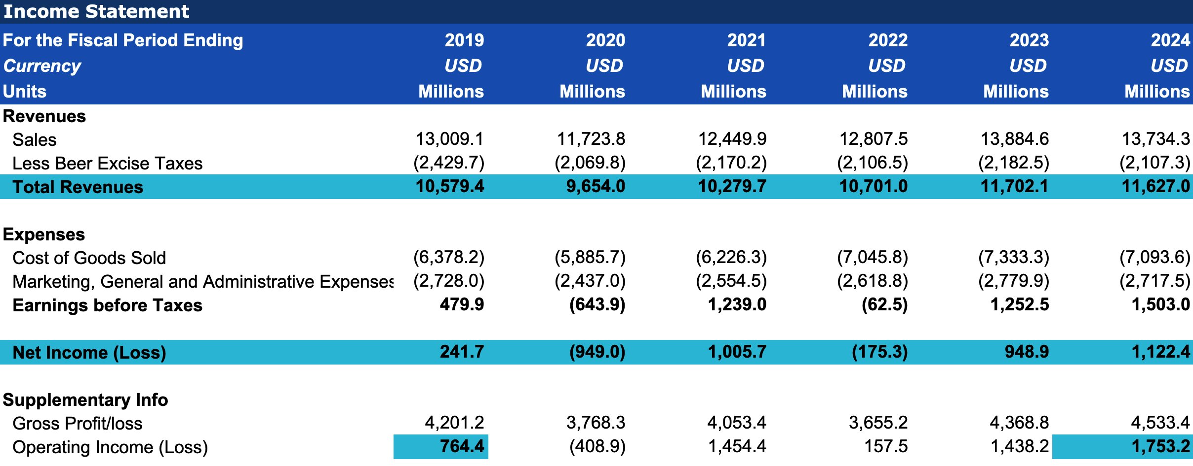

Exhibit 2: Common Size Analysis of 2024 Balance Sheet: Total Assets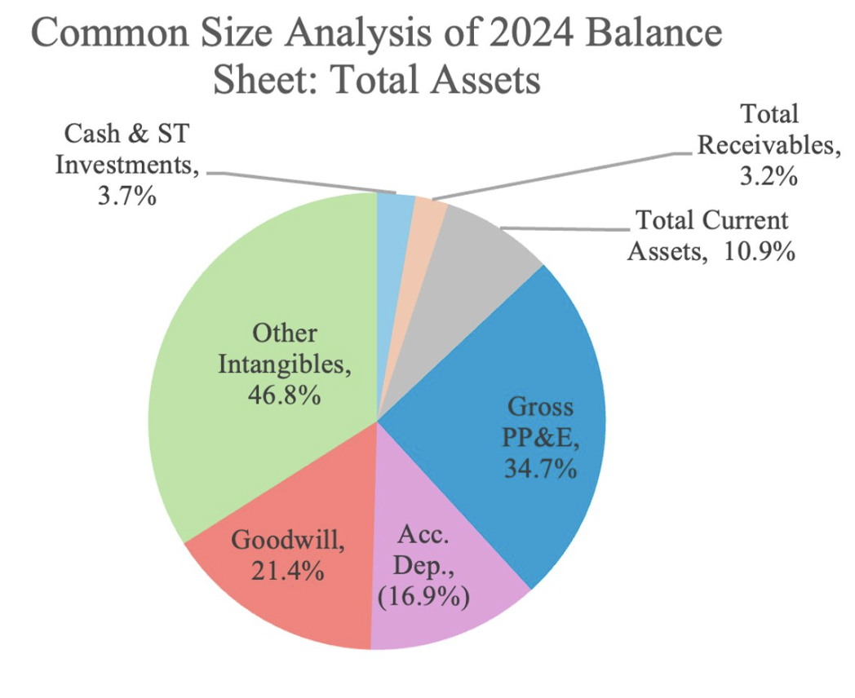
Exhibit 3: Molson Coors vs Peer Average Efficiency Ratios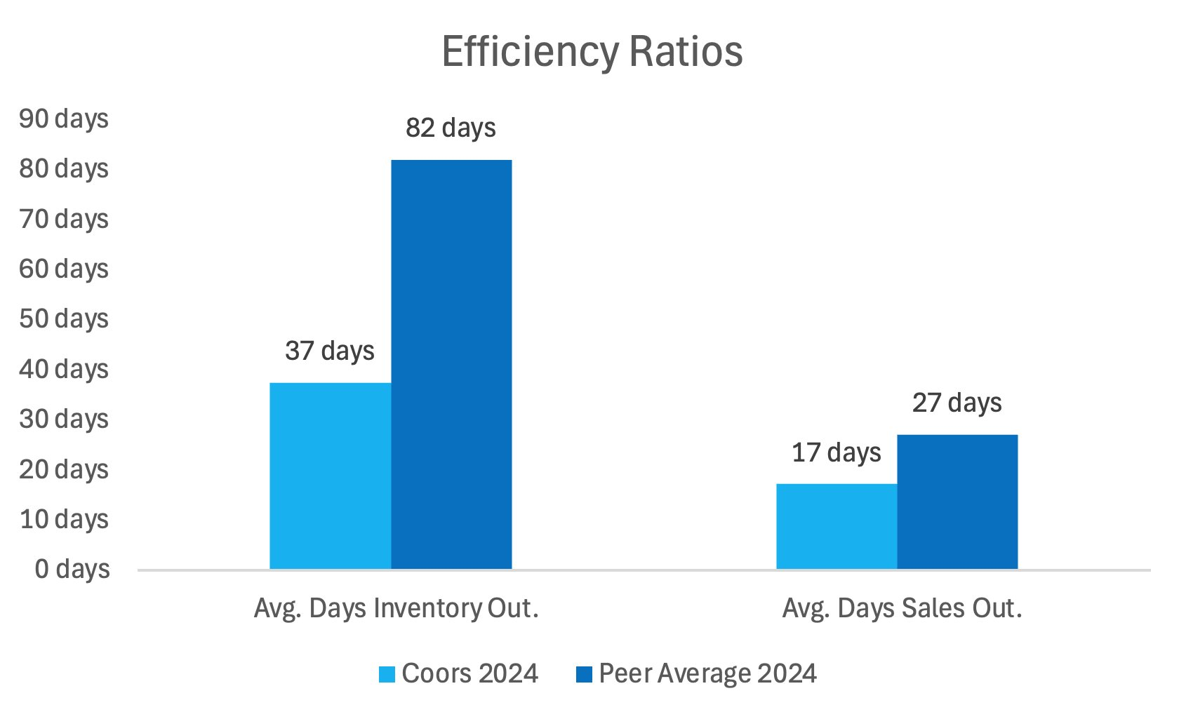
Exhibit 4: Global Market Cap of Alcoholic Beverage Industry by Year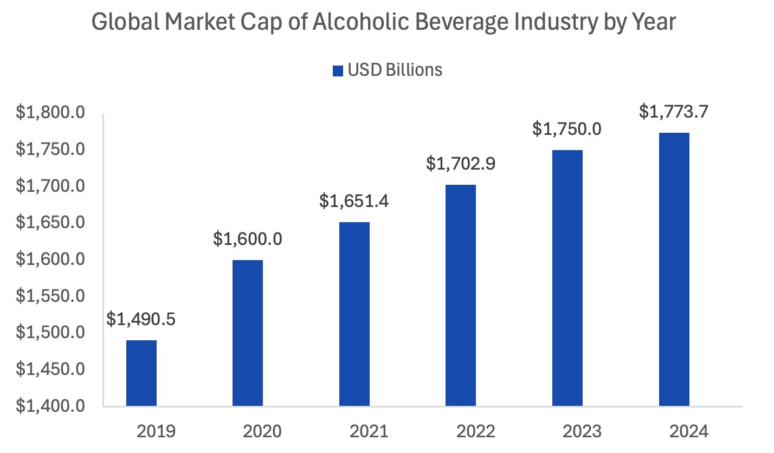
Exhibit 5: DCF Base (2024) vs Target (2029) Assumptions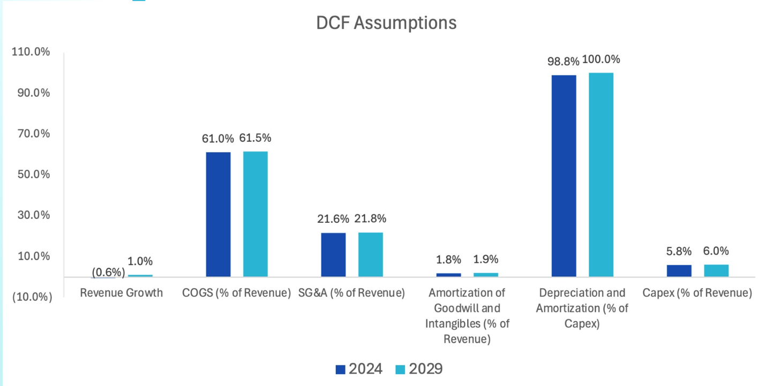
Exhibit 6: Sensitivity Analysis of Implied Equity Value per Share based on WACC (top row) vs Terminal Value (left column)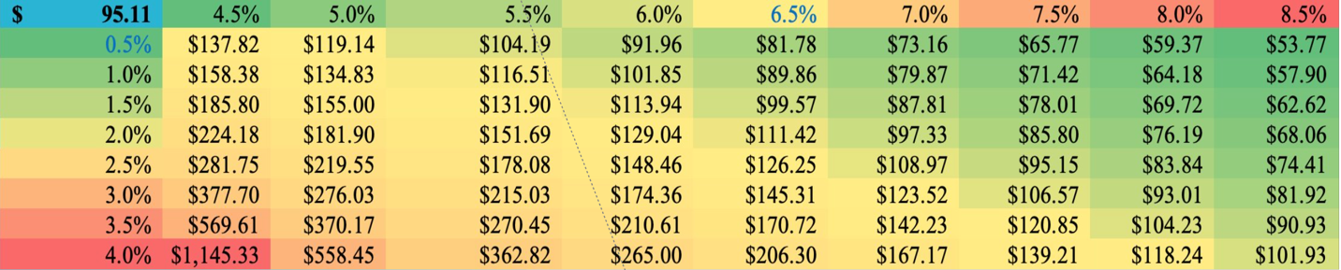
Exhibit 7: Impact of Aluminum Tariffs on Midwest Premium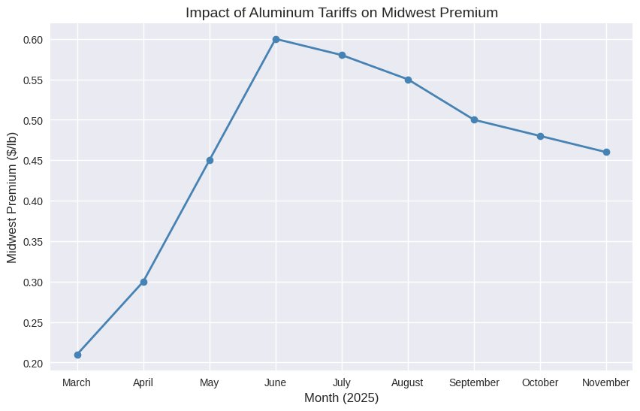

Exhibit 8: Ranges of Implied Price per Share Based on Relative Valuation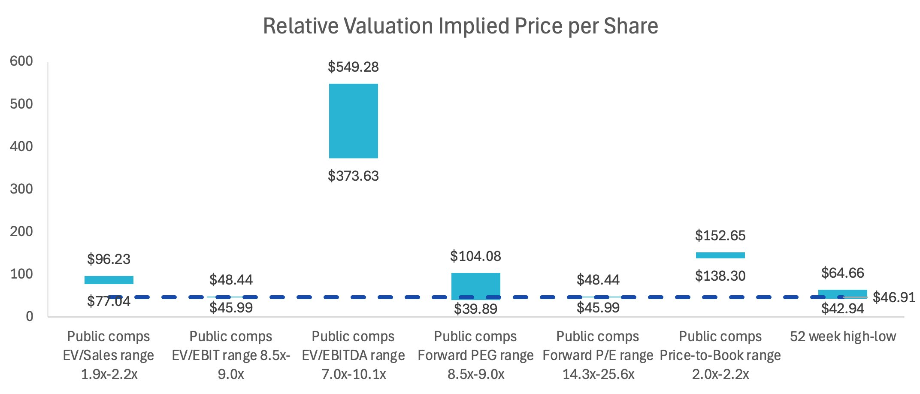Exhibit 9: Football Field Chart
Exhibit 10: DCF Assumptions and Explanations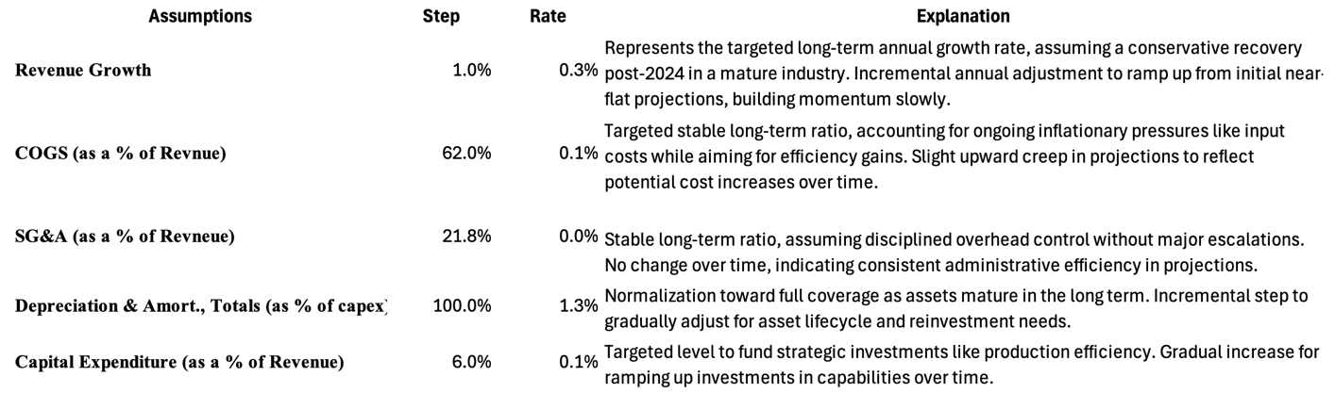
Exhibit 11: TAP Credit Health Score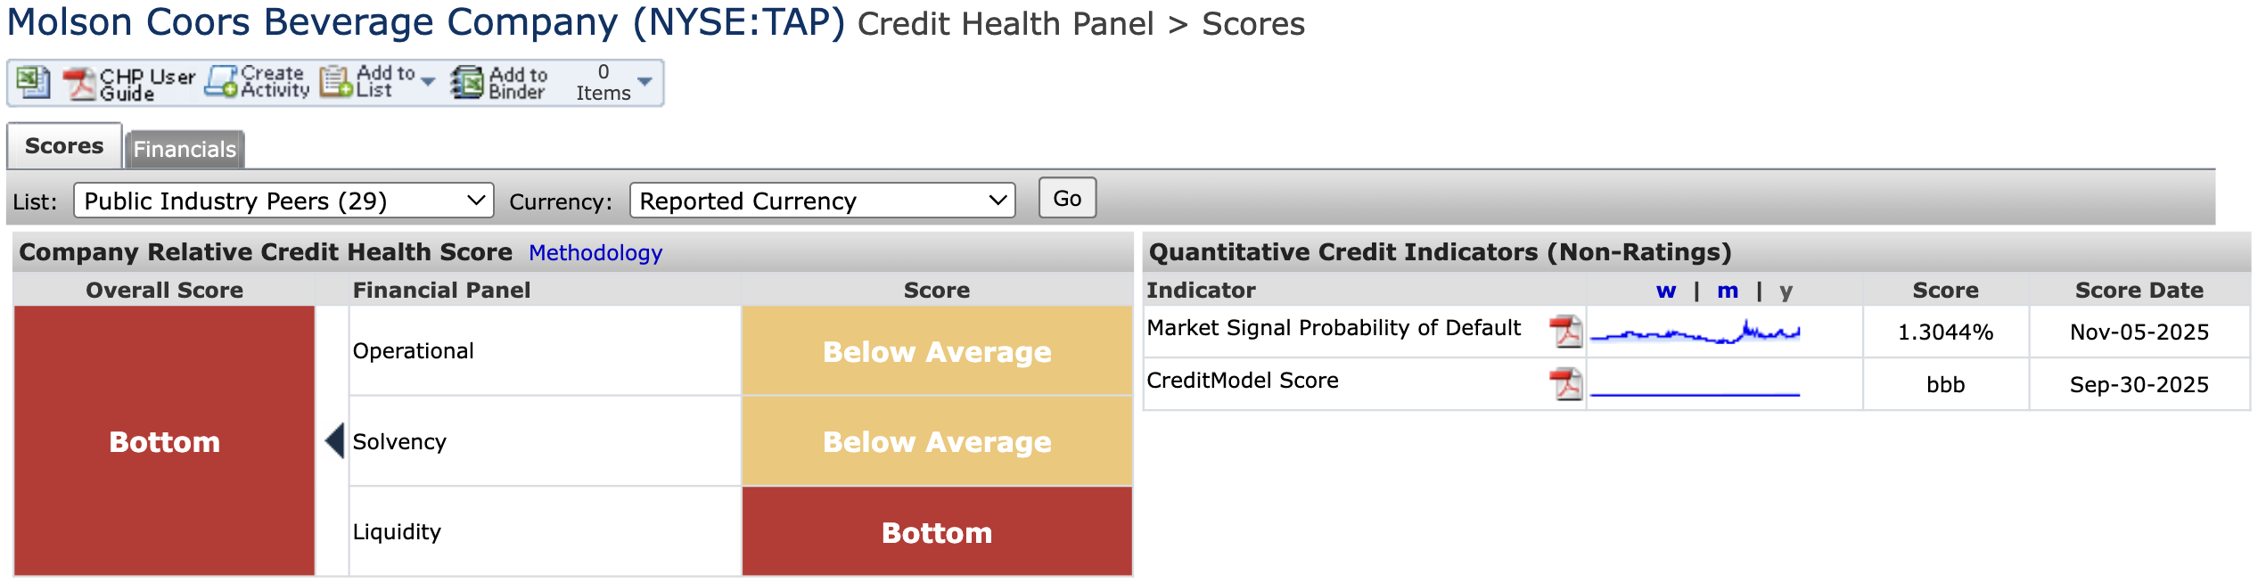
Exhibit 12: Damodaran Default Spread Based on Credit Rating 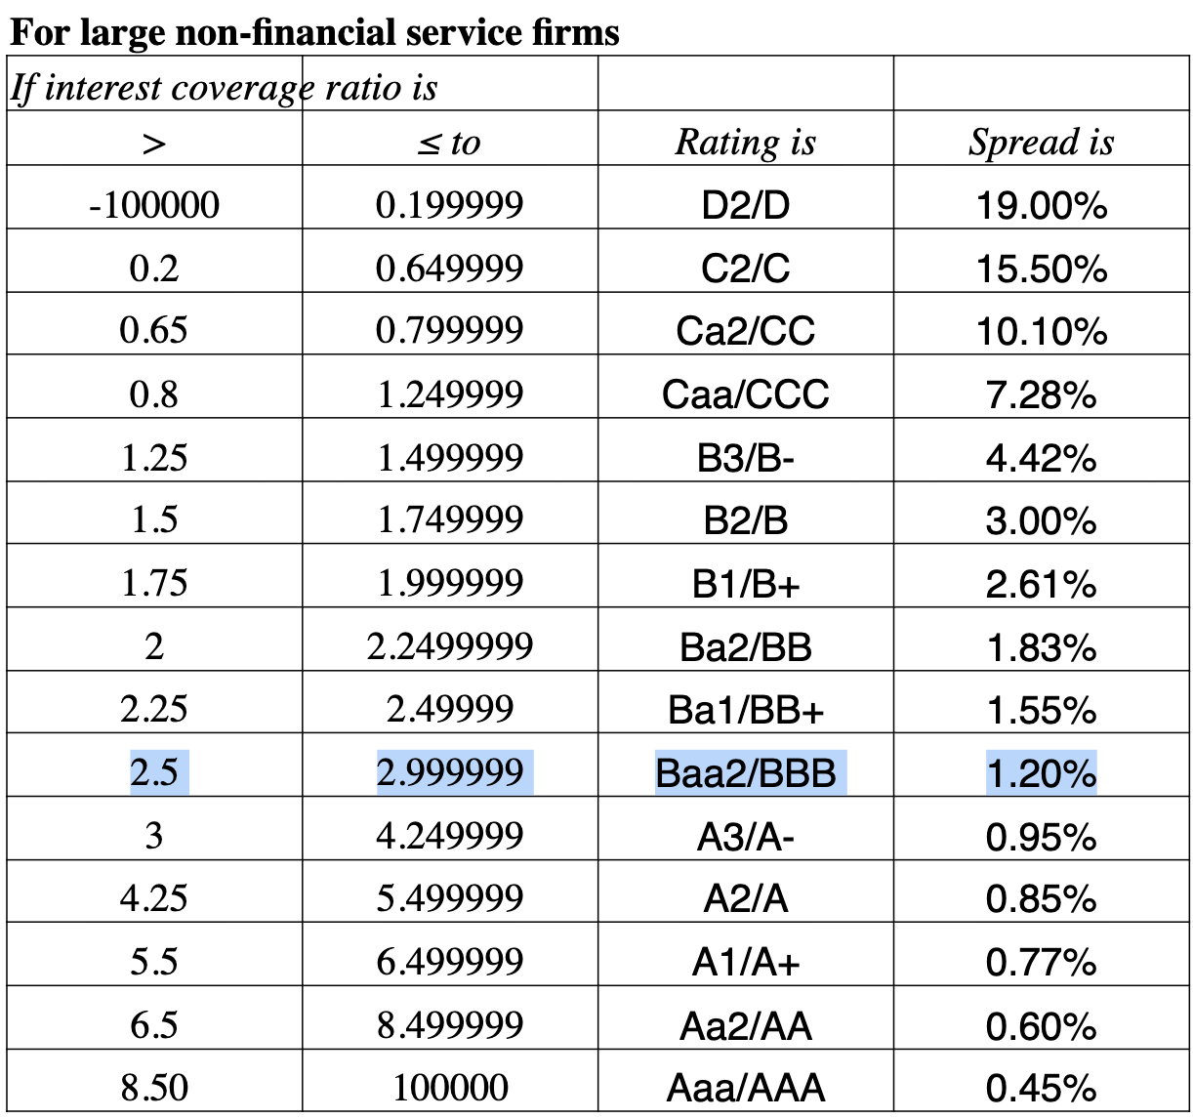

Work Cited
Accio. "U.S. Beer Market Share 2025." Accio Market Insights, 2025, www.accioinsights.com/beer-market-share-2025.
CSIMarket. "Molson Coors Beverage Company Market Share." CSIMarket, 2025, csimarket.com/stocks/competition.php?code=TAP.
NBWA (National Beer Wholesalers Association). "2025 Beer Industry Data." NBWA, 2025, www.nbwa.org/resources/industry-data.
uFoodin. "Global Beer Market Rankings 2025." uFoodin, 2025, www.ufoodin.com/beer-market-rankings-2025.
VinePair. "Top Beer Companies in the World 2025." VinePair, 2025, vinepair.com/articles/top-beer-companies-world-2025/.
"Molson Coors Beverage (NYSE:TAP) Stock Forecast & Analyst Predictions - Simply Wall St." Simply Wall St, Simply Wall St, 7 Nov. 2025, simplywall.st/stocks/us/food-beverage-tobacco/nyse-tap/molson-coors-beverage/future. Accessed 9 Nov. 2025.
Anheuser-Busch InBev. "FY Financial Report 2022." Anheuser-Busch InBev, 2023, www.ab-inbev.com/assets/pressreleases/2023/FY%2520Financial%2520Report%25202022.pdf. Accessed 9 Nov. 2025.

